**Second Increment**

In this Increment we skim through the Game code and identify the classes where the input events trigger.

We setup our Hbase configuration on the UMKC cloud and upload out Sensor data file and generate Sequence files

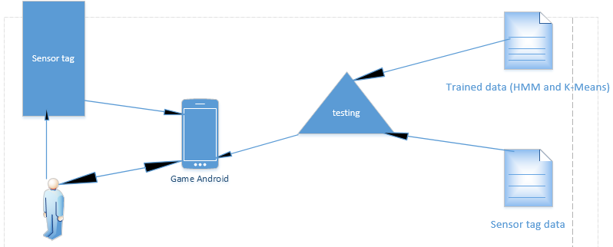

**Game Logic:**

We have basically 4 things to look at when we implement this game. They are shown below:

We can explain the working of the project by means of the following figures:

